Gymnastics for All – 776 GfA O8 Adv, Adv+, and Adv+ Challenge Competition 2019 Entrance Form
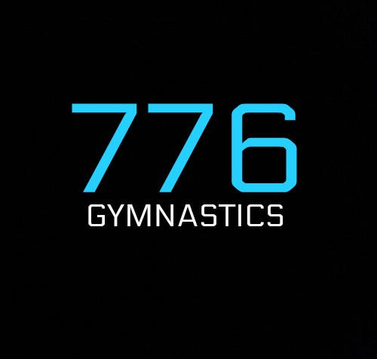
Hosted by 776 Gymnastics

Please complete and return this entry form to jack.duggan@british-gymnastics.org

Competition details
Venue | 776 Gymnastics Club
Time: | 09:00 |  | Date(s): |  | 26/05/2019
Competition organiser: | Kelly Westwood | 01623 620803 |  | info@776gymnastics.com

Club details
Club name: | [Insert name]
Club contact name and number: | [Insert contact name] | [Insert contact number] | [Insert contact email]
Expected/estimated number of spectators: | [Insert estimate no. of spectators]

Judges’ details
Name | Most relevant ‘judge’ qualification | BG no. | Contact no. | Emergency contact no.
[Insert name] | [Qualification] | [Insert BG no.] | [Insert no.] | [Insert no.]
[Insert name] | [Qualification] | [Insert BG no.] | [Insert no.] | [Insert no.]
If you can nominate more than one qualified judge that would be ideal to support the competition. If you don’t have a judge, please contact the British Gymnastics Competition Coordinator to discuss support options.

Coaches’ details
Name | Most relevant ‘coach’ qualification | BG no. | Contact no. | Emergency contact no.
Supervising coach
Must be BG Gold, Joint Gold or Life Member.
[Insert name] | [Qualification] | [Insert BG no.] | [Insert no.] | [Insert no.]
Assisting coaches (where appropriate)
Must be BG Silver (if level 1), Gold, Joint Gold or Life Member.
[Insert name] | [Qualification] | [Insert BG no.] | [Insert no.] | [Insert no.]
[Insert name] | [Qualification] | [Insert BG no.] | [Insert no.] | [Insert no.]
[Insert name] | [Qualification] | [Insert BG no.] | [Insert no.] | [Insert no.]
Helpers (where appropriate)
Don’t require membership but must be accompanied by a named coach (above) at all times.
[Insert name] | [Qualification] | [Insert BG no.] | [Insert no.] | [Insert no.]
[Insert name] | [Qualification] | [Insert BG no.] | [Insert no.] | [Insert no.]
Note: BG coaching ratios still apply.

Entry payment details
Cost per competing gymnast: £10
Cost per spectator:
Adult | Child (under 16 years) | Infant (under 5 years)
£5.00 | £5.00 | £5.00
Spectator fees are paid on the day of the event, on arrival to the venue.

BACs transfer:
Name: | 776 Gymnastics
Account number: | 24270168
Sort code: | 30 – 91 – 91
Reference: | 776 Adv Comp [Club name]
Please ensure the correct amount is paid upon entry. Without payment, entry will not be counted.

Gymnasts’ details
Gymnast name | Gender | Disability | D.O.B. | BG no. | Category
[Insert name] | Gender | Y / N | [Insert D.O.B.] | [Insert no.] | [Category]
[Insert name] | Gender | Y / N | [Insert D.O.B.] | [Insert no.] | [Category]
[Insert name] | Gender | Y / N | [Insert D.O.B.] | [Insert no.] | [Category]
[Insert name] | Gender | Y / N | [Insert D.O.B.] | [Insert no.] | [Category]
[Insert name] | Gender | Y / N | [Insert D.O.B.] | [Insert no.] | [Category]
[Insert name] | Gender | Y / N | [Insert D.O.B.] | [Insert no.] | [Category]
[Insert name] | Gender | Y / N | [Insert D.O.B.] | [Insert no.] | [Category]
[Insert name] | Gender | Y / N | [Insert D.O.B.] | [Insert no.] | [Category]
[Insert name] | Gender | Y / N | [Insert D.O.B.] | [Insert no.] | [Category]
[Insert name] | Gender | Y / N | [Insert D.O.B.] | [Insert no.] | [Category]
[Insert name] | Gender | Y / N | [Insert D.O.B.] | [Insert no.] | [Category]
[Insert name] | Gender | Y / N | [Insert D.O.B.] | [Insert no.] | [Category]
[Insert name] | Gender | Y / N | [Insert D.O.B.] | [Insert no.] | [Category]
[Insert name] | Gender | Y / N | [Insert D.O.B.] | [Insert no.] | [Category]
[Insert name] | Gender | Y / N | [Insert D.O.B.] | [Insert no.] | [Category]
[Insert name] | Gender | Y / N | [Insert D.O.B.] | [Insert no.] | [Category]
[Insert name] | Gender | Y / N | [Insert D.O.B.] | [Insert no.] | [Category]
[Insert name] | Gender | Y / N | [Insert D.O.B.] | [Insert no.] | [Category]
[Insert name] | Gender | Y / N | [Insert D.O.B.] | [Insert no.] | [Category]
[Insert name] | Gender | Y / N | [Insert D.O.B.] | [Insert no.] | [Category]
[Insert name] | Gender | Y / N | [Insert D.O.B.] | [Insert no.] | [Category]
[Insert name] | Gender | Y / N | [Insert D.O.B.] | [Insert no.] | [Category]
[Insert name] | Gender | Y / N | [Insert D.O.B.] | [Insert no.] | [Category]
[Insert name] | Gender | Y / N | [Insert D.O.B.] | [Insert no.] | [Category]
[Insert name] | Gender | Y / N | [Insert D.O.B.] | [Insert no.] | [Category]
[Insert name] | Gender | Y / N | [Insert D.O.B.] | [Insert no.] | [Category]
[Insert name] | Gender | Y / N | [Insert D.O.B.] | [Insert no.] | [Category]
[Insert name] | Gender | Y / N | [Insert D.O.B.] | [Insert no.] | [Category]
[Insert name] | Gender | Y / N | [Insert D.O.B.] | [Insert no.] | [Category]
[Insert name] | Gender | Y / N | [Insert D.O.B.] | [Insert no.] | [Category]
[Insert name] | Gender | Y / N | [Insert D.O.B.] | [Insert no.] | [Category]
[Insert name] | Gender | Y / N | [Insert D.O.B.] | [Insert no.] | [Category]
[Insert name] | Gender | Y / N | [Insert D.O.B.] | [Insert no.] | [Category]
[Insert name] | Gender | Y / N | [Insert D.O.B.] | [Insert no.] | [Category]
[Insert name] | Gender | Y / N | [Insert D.O.B.] | [Insert no.] | [Category]
If you wish to enter additional gymnasts, please complete another entry form.
Please list entries in order or level and age e.g. Under 8 – Age 5

Thank you

We are looking forwards to seeing you at our event

776 Gymnastics

